

Object Orientated Programming

Final Term Project

Object Oriented Analysis and Design

|  |  |
| --- | --- |
| Registration Numbers | 1. 2020-CS-103 2. 2020-CS-137 |
| Student Names | 1. Nabeel Yousaf 2. Haider Ali |
| Group Id | G-02 |
| Project Name | Carrefour Multinational Corporation |

Carrefour Multinational Corporation

* **Establishing vocabulary:**

The system is under control of a **CEO** which is acting as a head of the corporation. The CEO is basically the Owner of the whole system and he is responsible of adding the corporation managers and review the decision made by managers. A **corporation manager** is person who is responsible of all the functionalities of the corporation like registering **clients** allotting them the space and apply sales decide **GST**, **land tax** and **rent** of **shop**. So in other words he is the main active member of the system the next member is **counter holder** a counter holder is haired by the manager and his biggest responsibility is to calculate **bill** of the **customer**. The next actor of the system is client which invests and buy a shop in corporation and sale **products** he may belongs to a organization or be a standalone buyer he is allotted with an **account** and he may pays rent for his place. The last actor of the system **staff** these are also haired by manager and are responsible of sale products and do office tasks the **salesmen** are also another entity belongs to staff the client may take one or many salesmen according to the needs of his system but not free he needs to pay the **salary** and flounces to that salesman.

Now lets discuss the cycle of the system the system is leaded by CEO first the CEO adds corporation manager then the corporation manager has all the authority to register the clients the manager also responsible of allotment of space to the client. First of all the client send a **proposal** to take place on rent he needs to provide some basic information and the manager then on the bases of the information and interview selects or rejects the **requests** the **list** of all the selected and rejected requests are then sent to CEO the CEO the review them if some of them is un appropriate then he have the authority to forcedly reject it and he send **mail** to manager about the rejection cause. Only when the request is approved from both the manager and CEO the clients gets the confirmation **email** if the client receives the mail he also have the ability to cancel his proposal but he needs to send mail to manager about the cause and basically it happens when place or the rent is not appropriate so once the requests are accepted from both ends the manager needs to provide the client an **id** and **password** of his account just like the CEO assigns the manager so through this account the manager and client are linked they can send mails the client can print his **challans** and **receipts** more over the client is capable of keep the record of the goods and sales he may add products and view the amount of **sale** yet the client is restricted to pay rent GST and lands tax all the amount is uploaded on his account he may pay online or print it and submit to bank the client is capable to increase the amount and apply **sales** on **products** the manager also supposed to apply sales on specific days the more the client sale products the more he supposed to pay GST the GST is calculated on per item sale a specific amount of tax is paid to organization the bill is calculated on sales point where an employee opens up his account and start calculating the bill the bill is paid through cash or debit card each shop is assigned a unique **shop id** and the product belongs to that id then the price is added to that particular shop owner and the sales tax is added to company account. The client have option to withdraw his sales amount. The client can cancel his membership anytime but he needs to send an email to the manager before cancelling and manager also have ability to communicate with client before approving the cancellation request. The cancellation request is rejected if the tie is less than the contracted time.

* **Common vocabulary:**
* Adding person
* Editing person
* Deleting person
* Applying sales
* Sending emails
* Accepting proposals
* Rejecting proposals
* Sending proposals
* Paying bills
* **Identify Concepts:**

Add manager

Edit manger

Delete Manager

Add clients

Delete staff

Add staff

Edit clients

Edit Staff

Delete Clients

Delete products

Edit products

Add products

Accept CV

Send CV

Send Proposal

Reject CV

Set GST tax

Set Rent and Tax of shop

Reject Proposal

Accept proposal

Applying sales on system

Applying Sales on product

Email Sending

Allot Shop

Pay Tax and Rent

Calculate Bill

* Associations:
* Person Associations

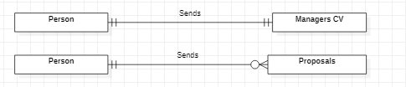

* CEO Associations

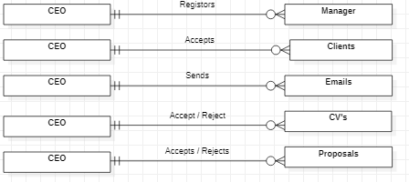

* Manager Associations

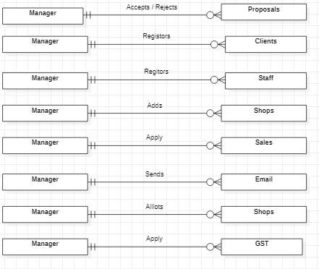

* Client Associations

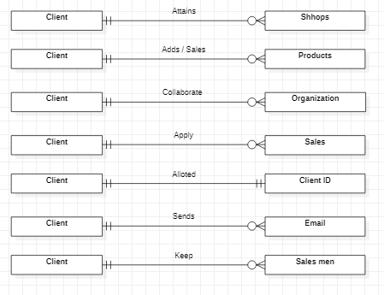

* Shop Association

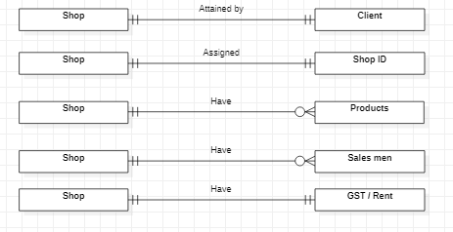

* Product Association

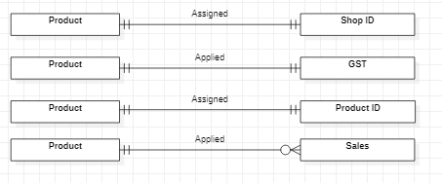

* Staff Association

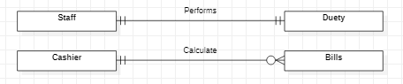

* Complete System Relationship Diagram ( ERD )

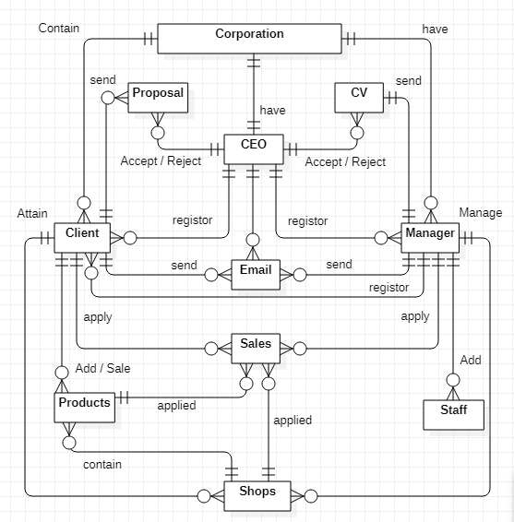

* Domain Model:

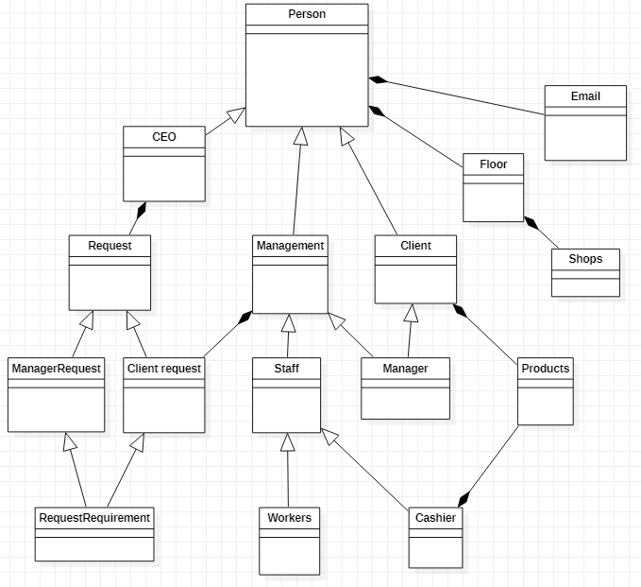

* **Finding Commonalities between concepts:**

In our project we have 4 kinds of persons one is CEO, Manager, clients and staff the classes have some same attributes like:

* Name
* Id
* City
* Cnic
* Email
* Phone no
* Password
* Gender
* Address
* Father name

So we rather than creating 4 complete classes we inherit them and keep the attributes in common parent class and then have four child classes with one different attribute.

* Identify Operation:

The system is under control of a **CEO** which is acting as a head of the corporation. The CEO is basically the Owner of the whole system and he is responsible of **adding** the corporation managers and **review** the decision made by managers. A corporation manager is people who is responsible of all the functionalities of the corporation like **registering** clients **allotting** them the space and **apply sales,** **decide GST** and land tax and **rent of shop**. So in other words he is the main active member of the system the next member is counter holder a counter holder is haired by the manager and his biggest responsibility is to **calculate bill** of the customer. The next actor of the system is client which invests and **buy a shop** in corporation and **sale products** he may belongs to a organization or be a standalone buyer he is allotted with an account and he may pays rent for his place. The last actor of the system staff these are also haired by manager and are responsible of sale products and do office tasks the salesmen are also another entity belongs to staff the client may take one or many salesmen according to the needs of his system but not free he needs to **pay the salary** and allowances to that salesman. Now let’s discuss the cycle of the system the system is leaded by CEO first the CEO **adds corporation manager** then the corporation manager has all the authority to **register the clients** the manager also responsible of **allotment of space** to the client. First of all the client **send a proposal** to take place on rent he needs to provide some basic information and the manager then on the bases of the information and interview **selects or rejects the requests** the list of all the selected and rejected requests are then sent to CEO the **CEO the review them** if some of them is un appropriate then he have the authority to **forcedly reject** it and he **send mail to manager** about the rejection cause. Only when the request is approved from both the manager and CEO the clients gets the **confirmation email** if the client receives the mail he also have the ability to cancel his proposal but he needs to send mail to manager about the cause and basically it happens when place or the rent is not appropriate so once the requests are accepted from both ends the manager needs to **provide the client an id and password** of his account just like the **CEO assigns the manager** so through this account the manager and client are linked they can send mails the client can **print his challans** and receipts more over the client is capable of **keep the record of the goods and sales** he may **add products** and view the amount of sale yet the client is restricted to **pay rent** gst and lands tax all the **amount is uploaded** on his account he may **pay online** or print it and submit to bank the client is capable to increase the amount and apply sales on products the manager also supposed to **apply sales** on specific days the more the client sale products the more he supposed to **pay gst** the gst is calculated on per item sale a specific amount of tax is paid to organization the bill is calculated on sales point where an employee opens up his account and start **calculating the bill** the bill is paid through cash or debit card each shop is **assigned a unique shop id** and the product belongs to that id then the price is added to that particular shop owner and the sales tax is added to company account. The client have option to **withdraw his sales amount**. The client can cancel his membership anytime but he needs to send an email to the manager before cancelling and manager also have ability to communicate with client before approving the cancellation request. The cancellation request is rejected if the tie is less than the contracted time.

